**Lecture Notes Prepared by: SAINATH**

**__________________________________________________________________________________**

# PRACTICE QUESTIONS

**DEPT TABLE :**

|  |  |  |
| --- | --- | --- |
| **Dept No.** | **Dname** | **LOC** |
| 20 | Research | Dallas |
| 10 | Accounting | New York |
| 30 | Sales | Chicago |
| 40 | Operations | Boston |

**EMP TABLE :**

|  |  |  |  |  |  |  |  |
| --- | --- | --- | --- | --- | --- | --- | --- |
| **Empno** | **Ename** | **Job** | **MGR** | **Hiredate** | **Sal** | **COMM** | **Dept No.** |
| 7369 | Smith | Clerk | 7902 | 17-Dec-80 | 800 |  | 20 |
| 7499 | Allen | Salesman | 7698 | 20-feb-81 | 1600 | 300 | 30 |
| 7521 | Ward | Salesman | 7698 | 22-Feb-81 | 1250 | 500 | 30 |
| 7566 | Jones | Manager | 7839 | O2-Apr-81 | 2975 |  | 2- |
| 7654 | Martin | Salesman | 7698 | 28-Sep-81 | 1250 | 1400 | 30 |
| 7698 | Blake | Manager | 7893 | 01-May-81 | 2850 |  | 30 |
| 7782 | Clark | Manager | 7839 | 09-Jun-81 | 2450 |  | 10 |
| 7788 | Scott | Analyst | 7566 | 09-Dec-82 | 3000 |  | 20 |
| 7839 | King | President |  | 17-Nov-81 | 5000 |  | 10 |
| 7844 | Turner | Salesman | 7698 | 08-Sep-81 | 1500 | 0 | 30 |
| 7876 | Adams | Clerk | 7788 | 12-Jan-83 | 1100 |  | 20 |
| 7900 | James | Clerk | 7698 | 03-Dec-81 | 950 |  | 30 |
| 7902 | Ford | Analyst | 7599 | 03-Dec-81 | 3000 |  | 20 |
| 7934 | Miller | Clerk | 7782 | 23-Jan-82 | 1300 |  | 10 |

**SAL GRADE TABLE :**

|  |  |  |
| --- | --- | --- |
| **Grade** | **Losal** | **HISAL** |
| 1 | 700 | 1200 |
| 2 | 1201 | 1400 |
| 3 | 1401 | 2000 |
| 4 | 2001 | 3000 |
| 5 | 3001 | 9999 |

**SELECT :**

1. Display all the information of the EMP table.

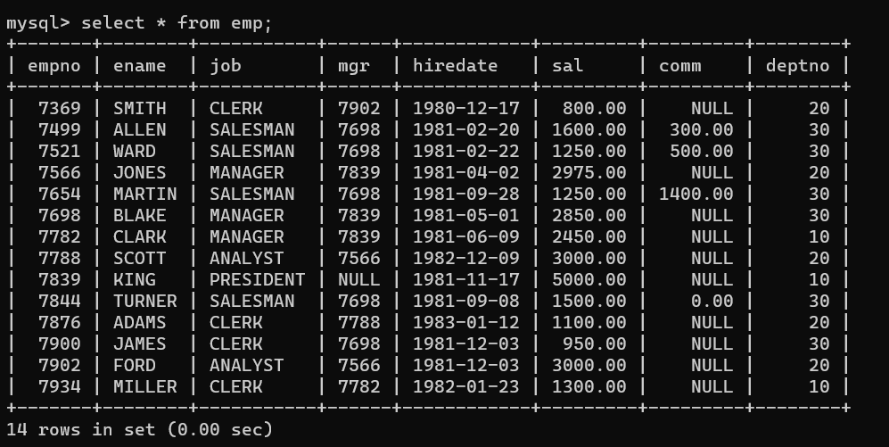

1. Display unique Jobs from EMP table.

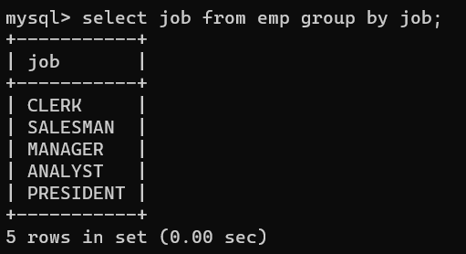

1. Display the details of all MANAGERS.

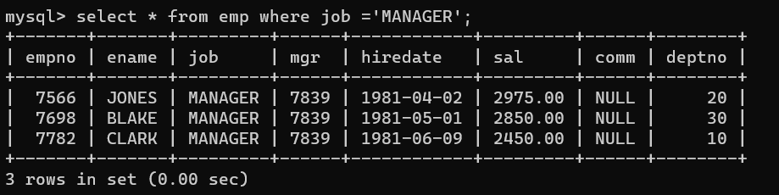

1. List the emps who joined before 1981.

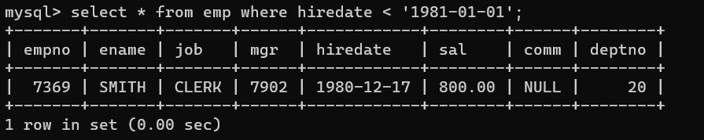

1. Display the Empno, Ename, Job, Hiredate, and experience of all Managers.

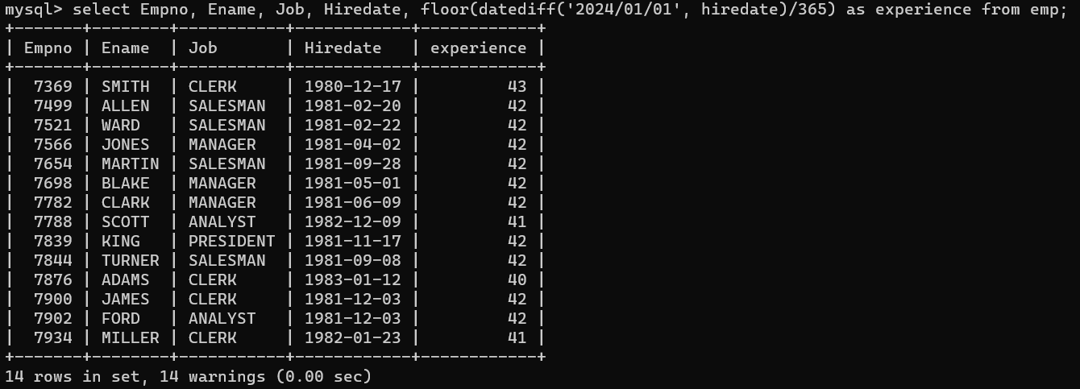

1. List the Empno, Ename, Sal, Exp of all emps working for Mgr 7639.

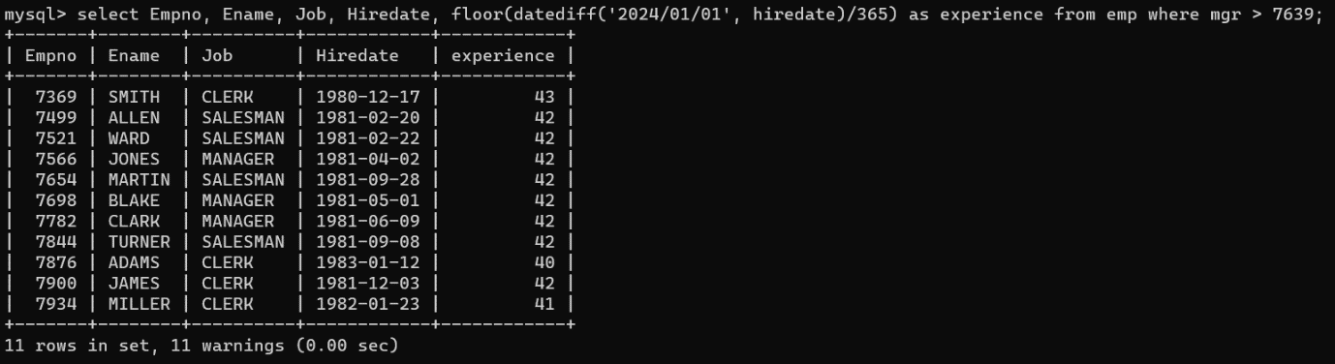

1. Display all the details of the emps whose Comm. Is more than their Sal.

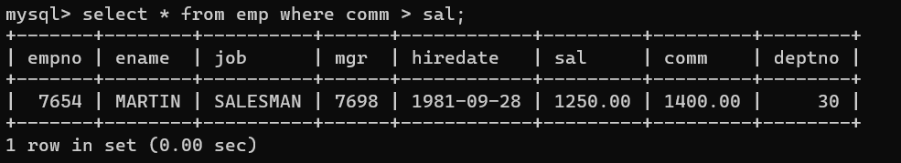

1. List the emps along with their Exp and whose Daily Sal is more than Rs. 100.

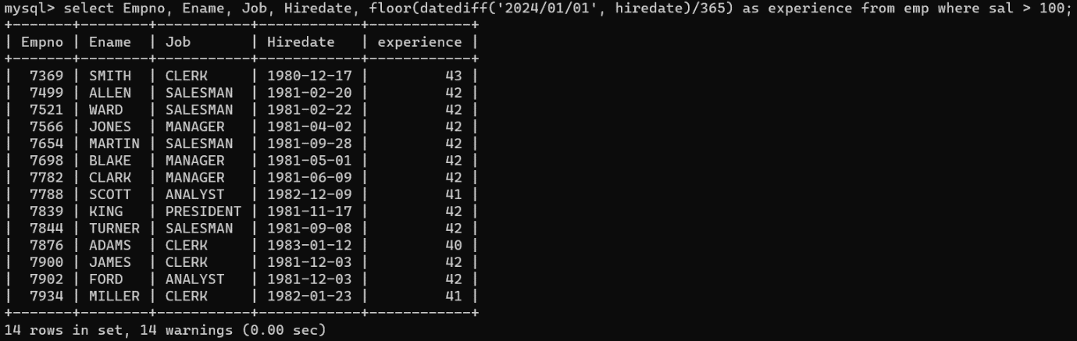

1. List the emps who are working for the Deptno 10 or 20.

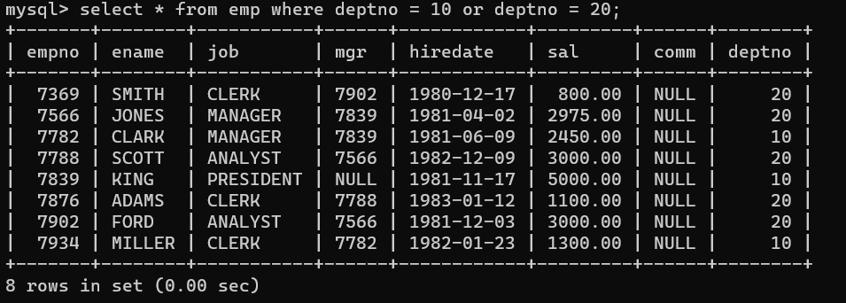

1. List the emps who are working under any Manager.

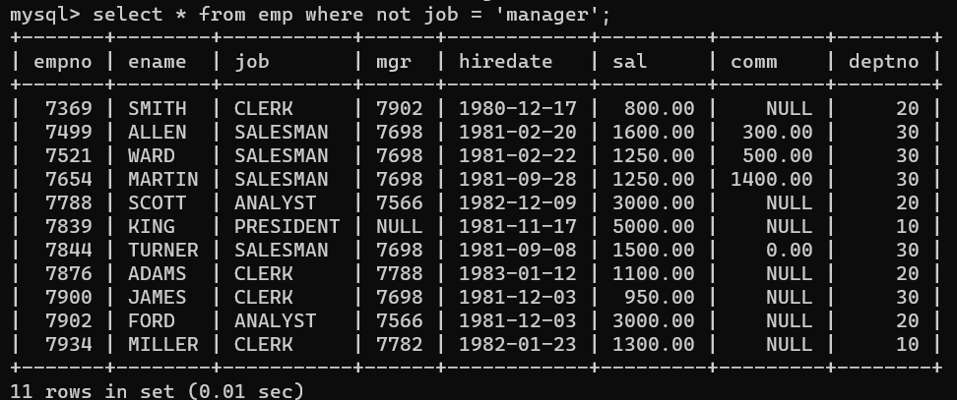

1. List all the Clerks of Deptno 20.

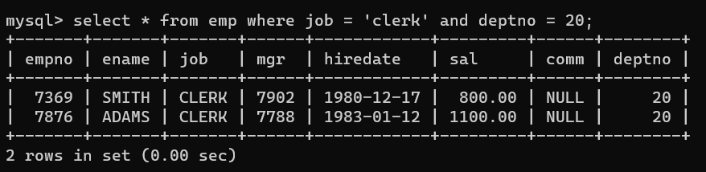

1. Display the details of SMITH.

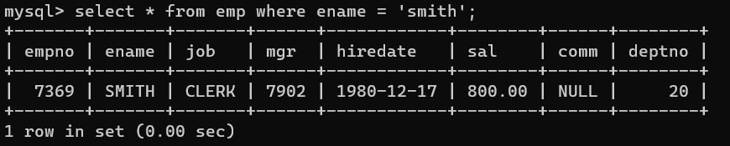

1. Display the Empno, Ename, Deptno from EMP table.

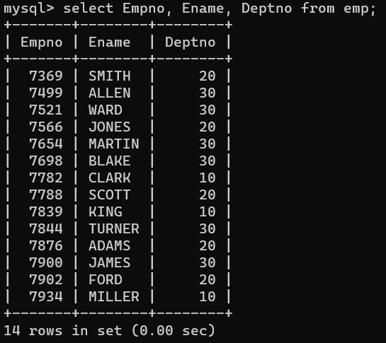

1. Write a query to display the Empno and the Deptno of all emps.

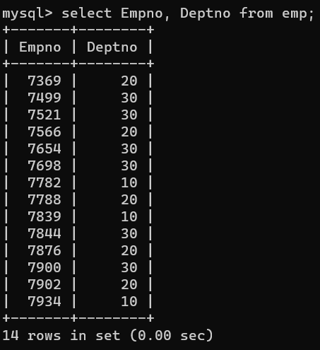

1. Display the unique Depts of emps.

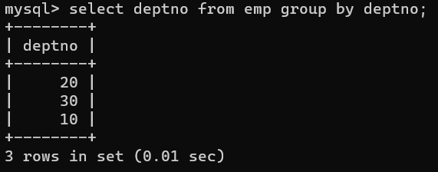

1. List the emps whose Salary is more than 3000 after giving 20% increment.

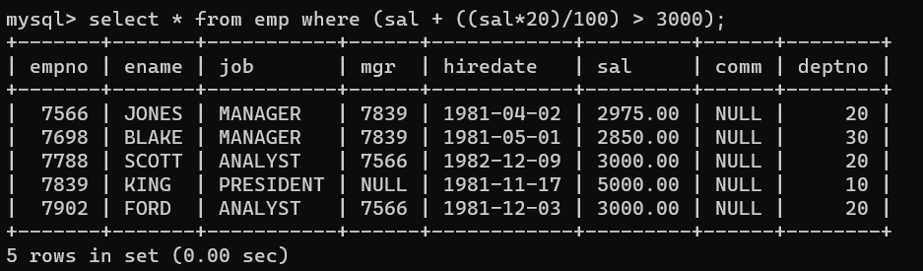

1. List the Ename and Sal increased by 15% and expressed as No. of Dollars.

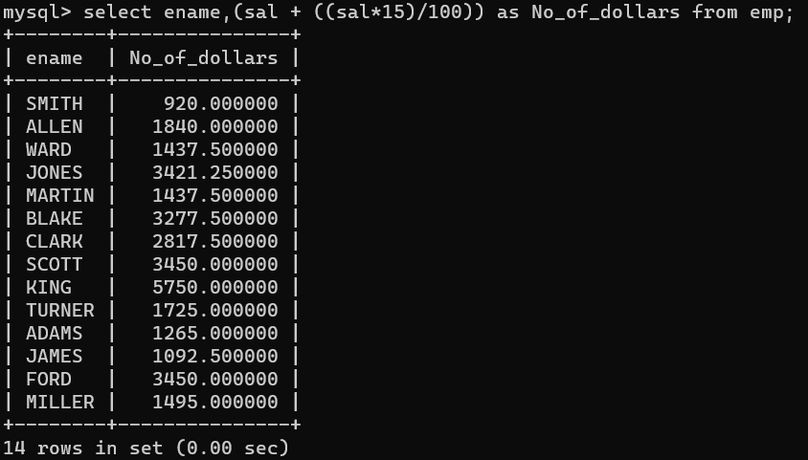

1. Produce the output of EMP table EMP_AND_JOB for Ename and job.

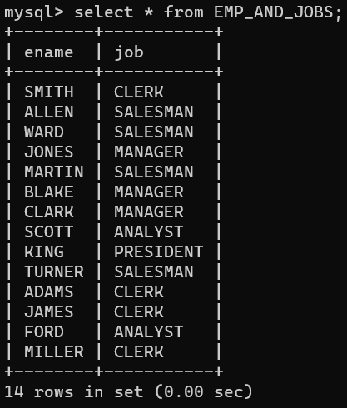

1. Display the Empno, Ename, Salary of all Managers.

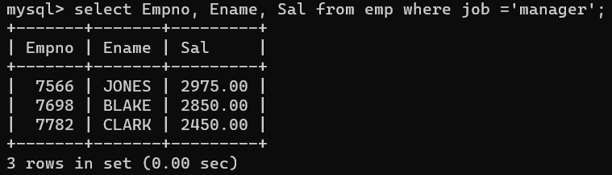

1. Define a variable representing the expression used to calculate on emps total annual remuneration use the variable in a statement which finds all emps who can earn 30000 a year or more.

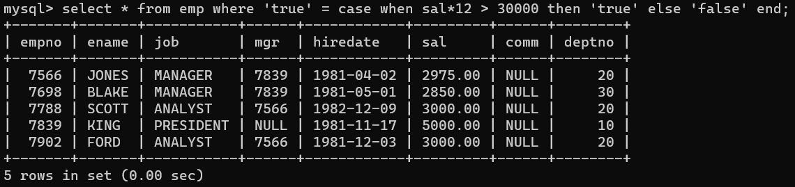

1. Check whether all the emps numbers are indeed unique.
2. List the Empno, Sal and Comm of emps.

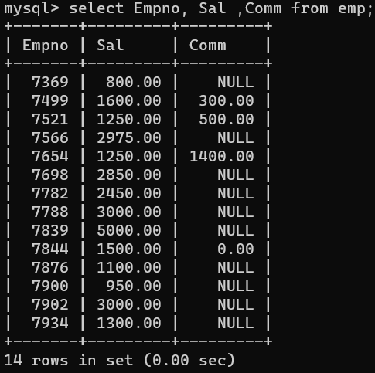

1. Display the unique dept with Jobs.
2. Display the details of Blake.

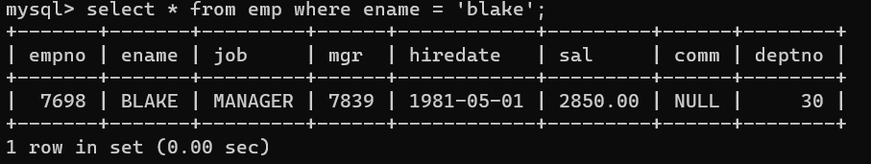

1. List all Clerks.

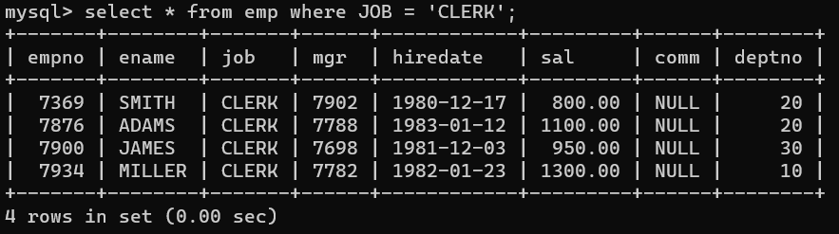

1. List all emps joined on 1 may 1981.

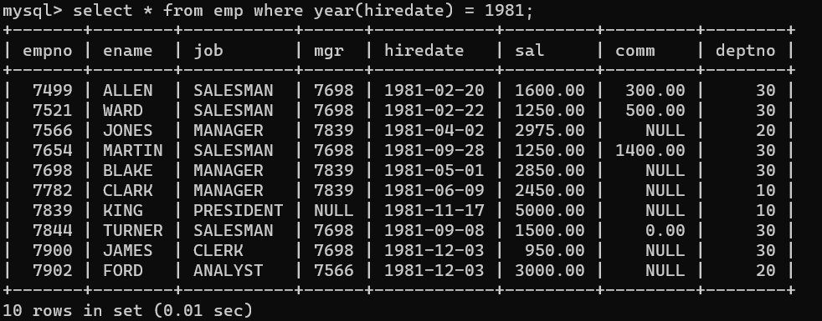

1. List the emps whose Salaries are less than 3500.

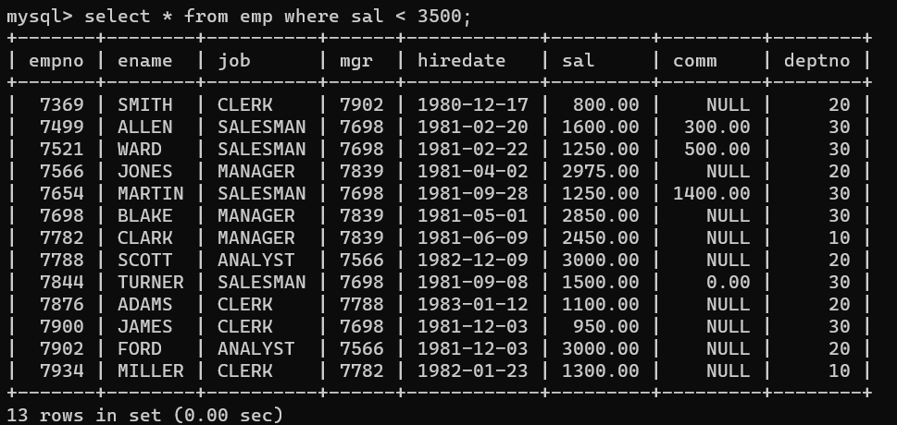

1. List the emps Empno, Ename, Sal of all emp joined before 1 Apr 1981.

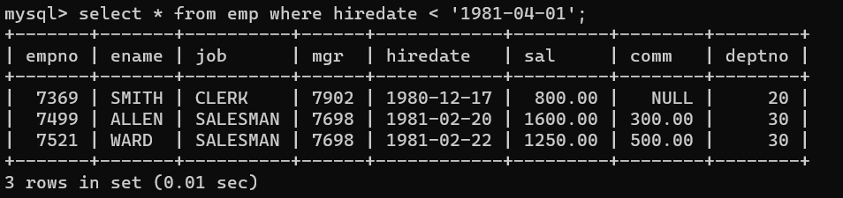

1. List the emps whose exp is more than 10 years.

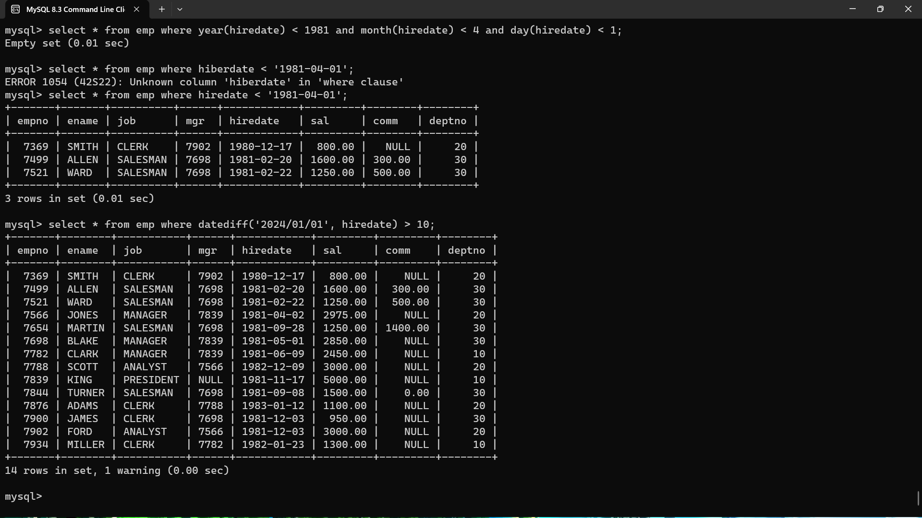

1. List the emps who are working as Manager.

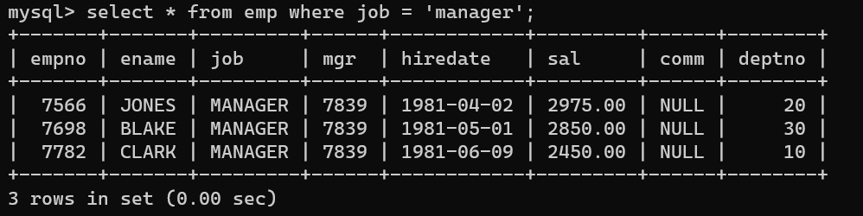

1. List the emps who are working as clerks and exp is more that 8 Years.

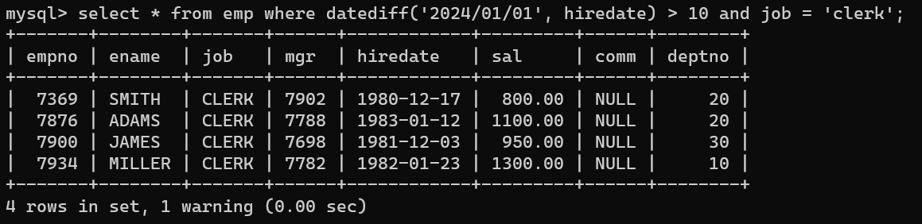

1. List the Empno, Ename, Sal, Job of emps with the annSal <34000 but receiving some comm. Which should not be greater than Sal and the designation should be Salesman working for dept 20.
2. List all the Salesmen who are receiving Comm.

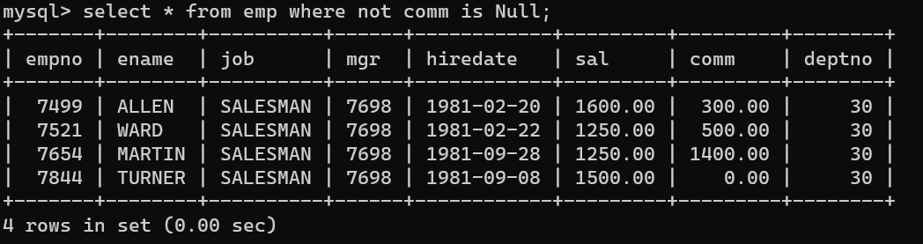

1. List all the Salesmen of the Dept 30 whose Comm. Is more than their Salary.

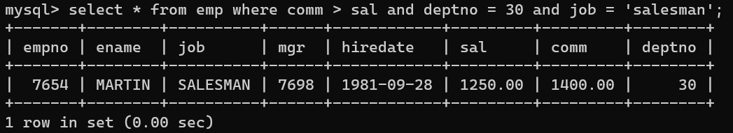

1. Generate all the 3 digit numbers.
2. Display the first 5 records of the EMP table.

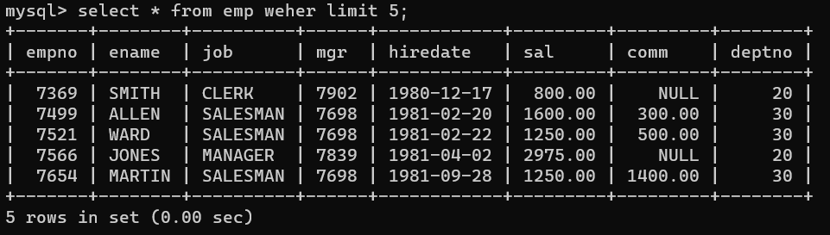

1. List the emps empno qw, ename, job, sal of all emps.

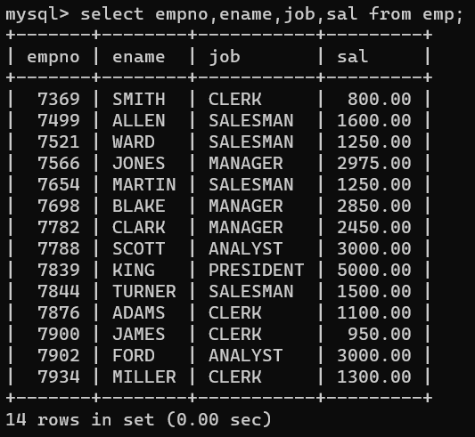

1. List all the unique deptno of emps.

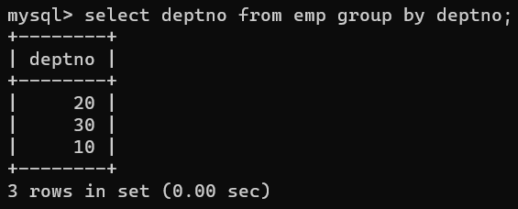

1. List all the unique jobs along with deptno.
2. List all the details of ‘Miller’.

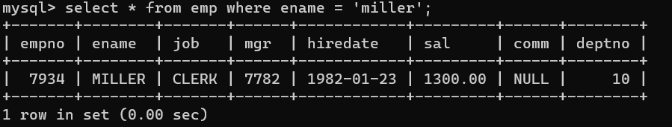

1. list the details of dept 10.

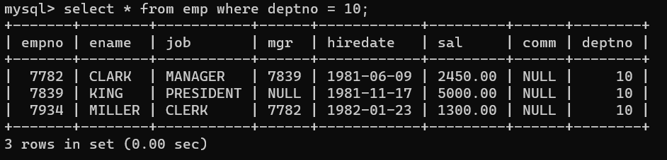

1. List all the ‘SALESMAN’.

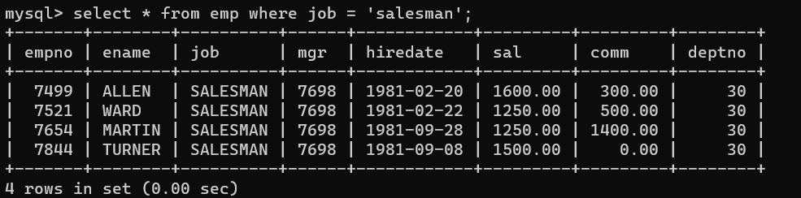

1. List all the emps who joined before 1984.

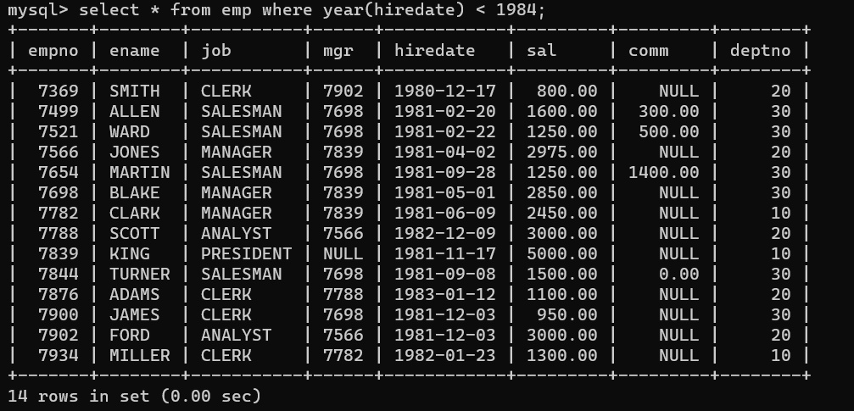

1. List all the emps whose Sal>2500.

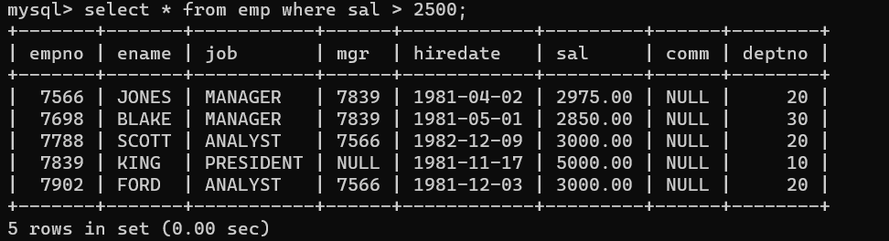

1. List all the emps who are working since 1st April 1982.

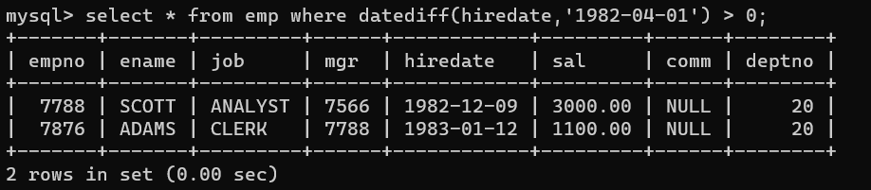

1. List the empno, ename, sal, Daily sal of all emps.

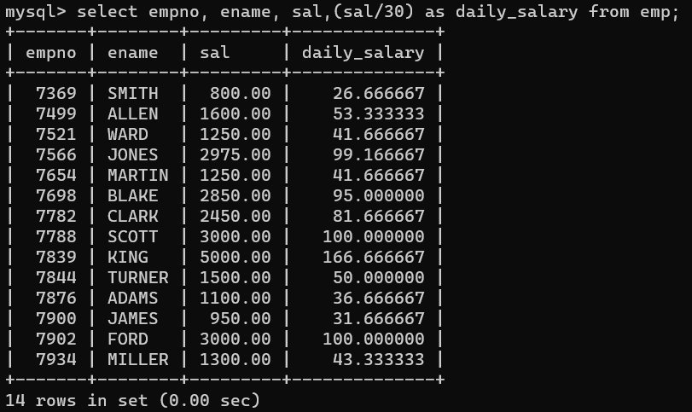

1. List the empno, ename, sal, experience of all ‘Analysts’.

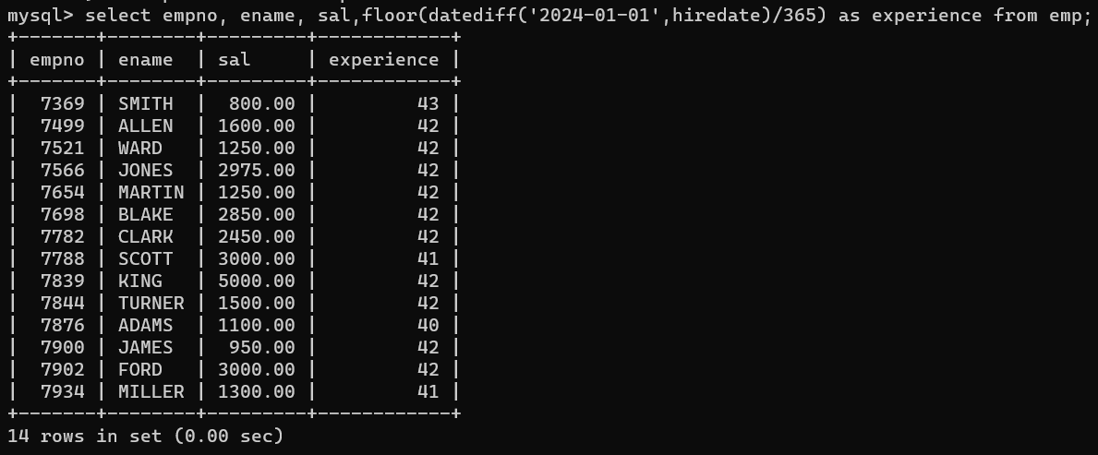

1. List the emps whose exp>6.5 Y.

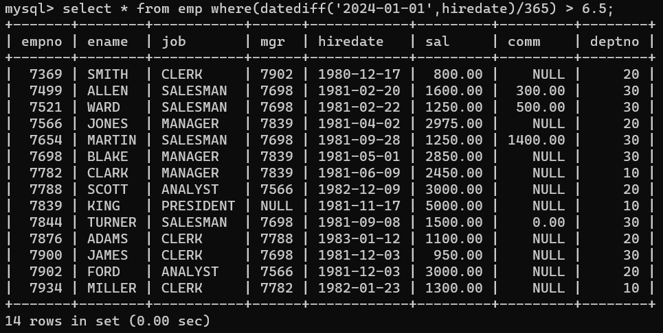

1. List the emps who joined in 2nd half of 1981.

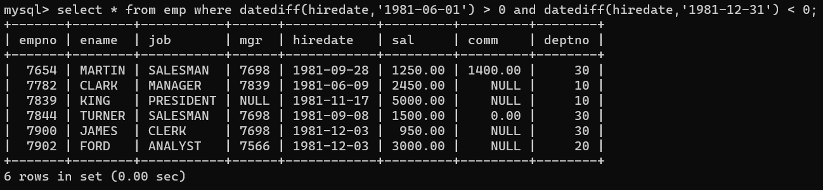

1. List all the emps in dept 10 who are working as Clerks.

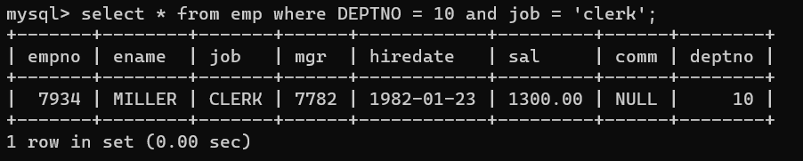

1. List the emps who joined before 1985 and salary is more than 3000.

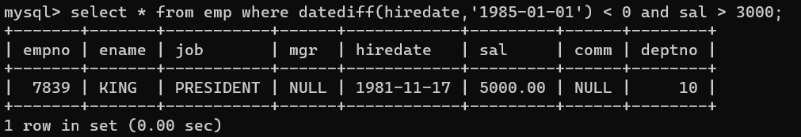

1. List the Exp of Grade 3 emps.

**SUB QUIRES:**

1. List the details of the emps whose salaries more than the employee BLAKE

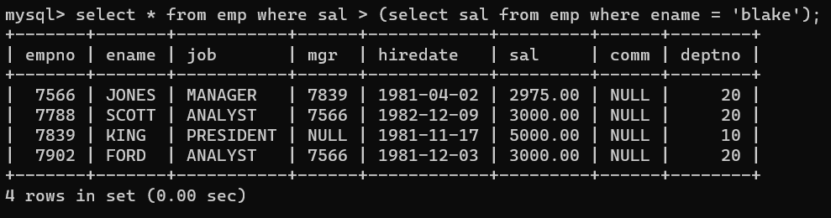

1. List the emps whose Jobs are as ALLLEN.

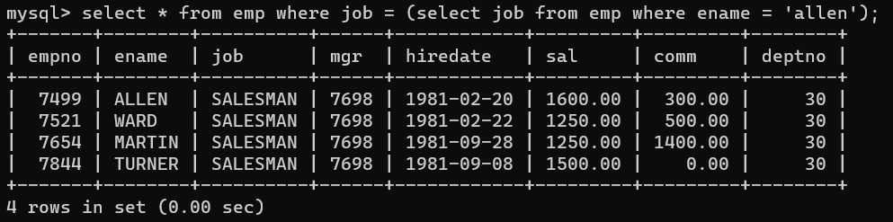

1. List the emps who are senior to King.

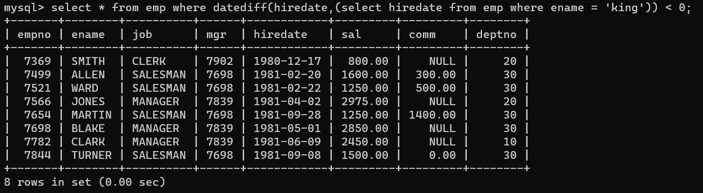

**UPDATE:**

1. Transfer Blake to Deptno 30.

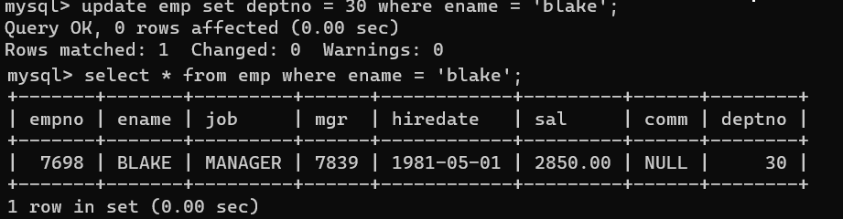

1. Transfer the emps of Dept 10 to 20.

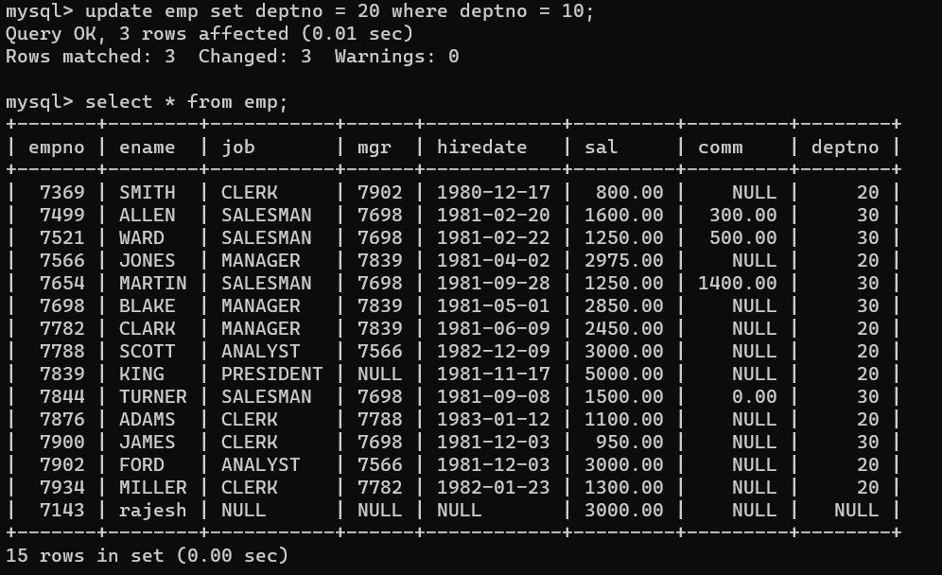

1. Transfer the emps Chicago to Dallas.
2. Update the Salary of ‘ALLEN’ with the highest paid emp of Grade 2 and transfer him to Blake’s Dept and change the Mgr to Blake.
3. Increment the Salaries by 2% and add a Comm of 250 to the existing Comm and changing the Manager to Jobs of all ‘Salesman’ whose Salaries os more than or equal to 1000.
4. Replace the Sal of most senior ‘CLERK’ with the most senior employee Sal of Grade

3.

1. Transfer all the emps of 10-20-,20-30,30-40,40-10.

a. Update the Salary of each employee by 10% increment who are not eligible for Comm.

1. Increment the Sals of the emps be 2%.
2. Increment the Sal of all the Clerks by Rs.200 and change their Mgr to 7654.
3. Change the Mgr of all Chicago related emps Blake.
4. Write update statement to increment the Sal of grade 2 by 1.2%.
5. Transfer the emps to analyst Dept and give the Sal of smith plus 500 to those belongs to grade 3 working at New York or Dallas with an exp>7y whose name should not be 4 chars.
6. Increment the salaries of all Clerks by 2%.
7. Transfer the emps Dept 10 to 20.
8. Update Mgr 7788 to those are working under the Mgr 7839 & increase the sal by 2%.

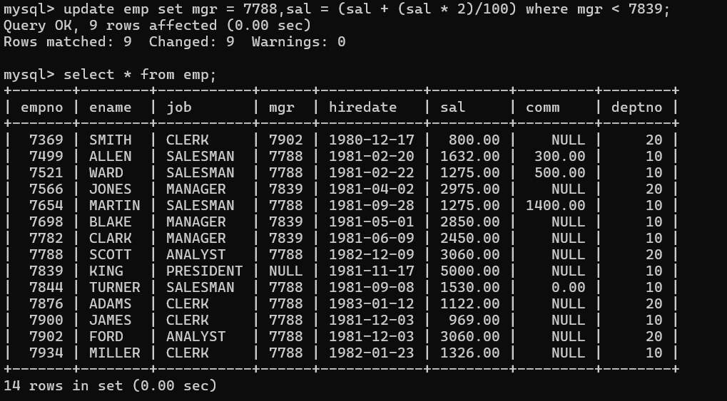

1. Transfer the emps of Chicago to Dept 20.

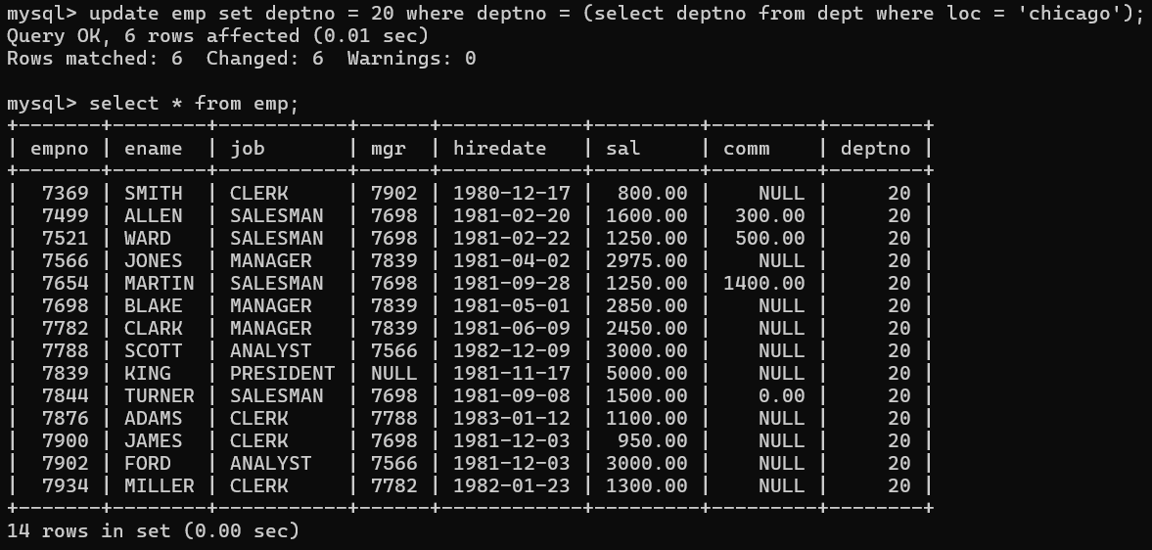

1. Update the Deptno of Sales dept for those emps working at Deptno 10.

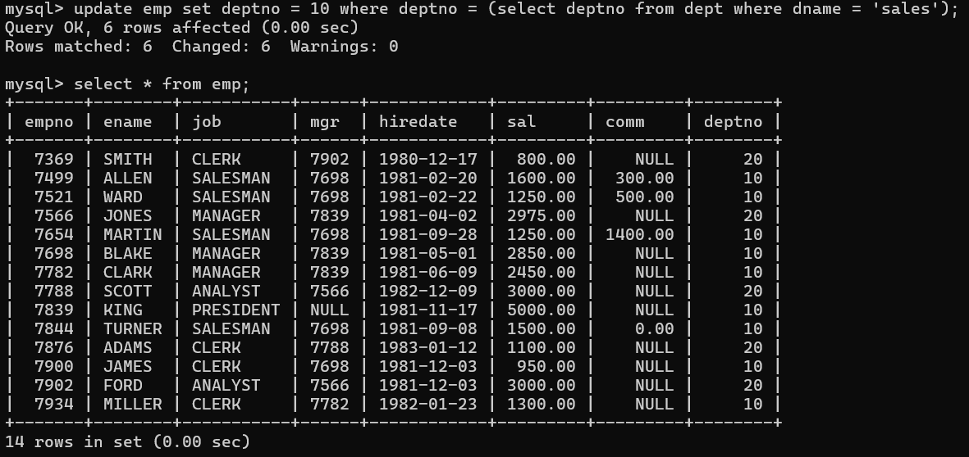

1. Update the salary of Smith with the highest paid salary emp of Salesman more than 10Y exp.

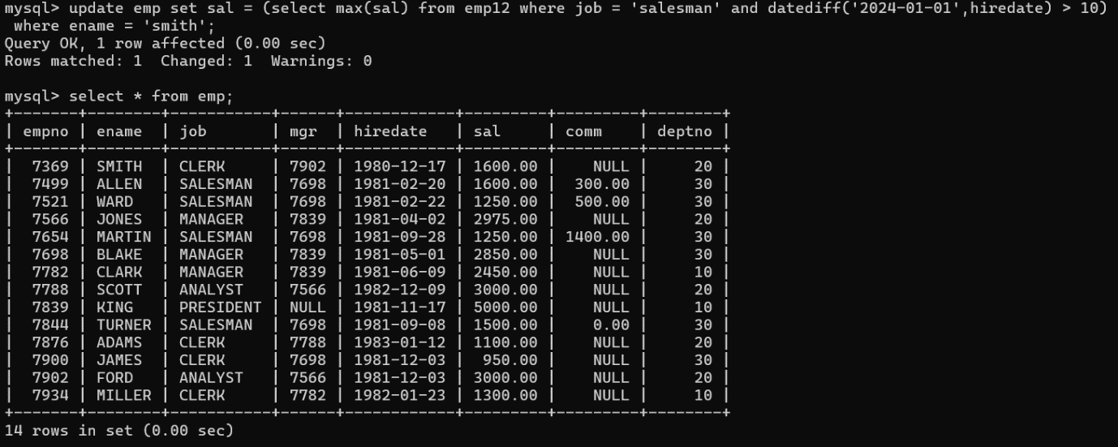

1. Increment the sal of grade 2 emps by Rs.300.

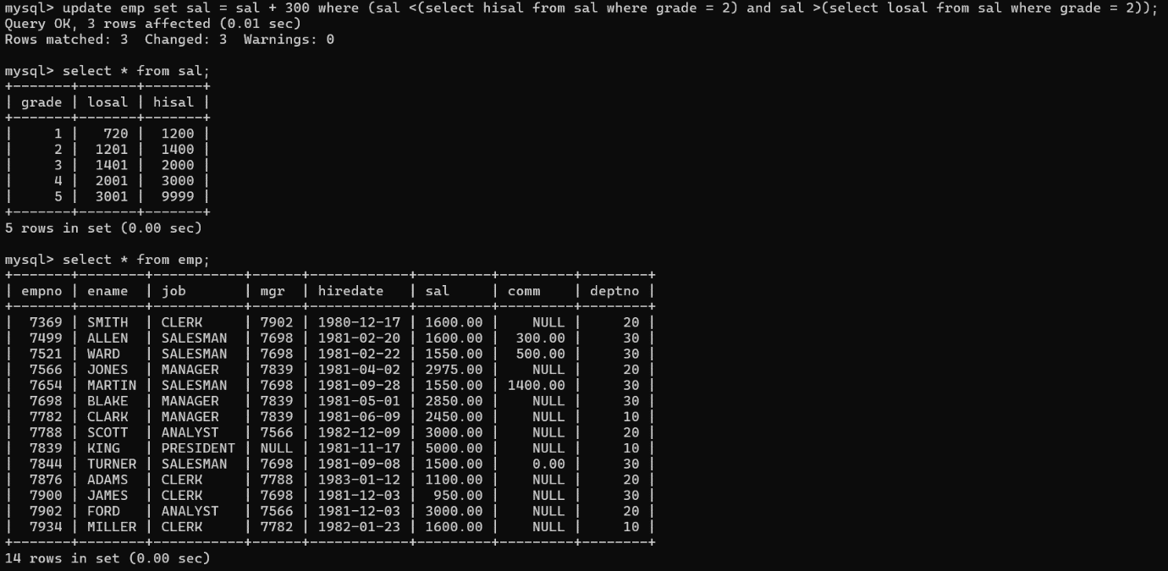

1. Update the sal of Allen with the highest Sal of any Clery belongs to grade 2 or 3 working at Chicago or Dallas and king as Manger.
2. Change the mgr to 7788 for those working for the mgr 7369.
3. Add 250 to the comm of all salesmen who are receiving some comm..
4. Change the deptno of Blake to 30 and also change the job as President with an increment in the Salary%.
5. Transfer the emps of dept no 20 to Sales dept.
6. Replace the Sal of Smith with the highest paid Salesman with exp>10 years.
7. Give an increment of Rs.300 to all emps of grade 2.
8. Replace the Sal of Allen with the highest paid Clerk of New York or Chicago.

**DELETE:**

1. Delete all the information of ‘Salesmen’.
2. Delete all the Managers who are working under king the Sal ranging from 3500 to 4000 joined after second half of 981.
3. Delete all Grade 1 emps.
4. Write a query to delete all the Salesman of Sales dept.
5. Delete the most recently hired employee of Deptno 30.
6. Delete the records where no of emps in a particular dept is less than 3.
7. Delete the emps who joined in the company before 10 years back.
8. Delete all the emps working in Boston.
9. Delete the emps who joined in the month of Jan 1981.
10. Delete all the emps who working under Blake with exp>7year.
11. Delete the information of Miller.
12. Delete all emps working under Blake.
13. Delete the emps who joined most recently under king.
14. Delete the Grade 1 and 2 emps.
15. Delete the emps who belongs to Grade 1 or 2 working at Chicago joined in any month of the first half of 81.
16. Delete the emps of Mrg 7654.
17. Delete the emps with experience <4 and whose Job is ending with ‘MAN’. 100. Delete the emps of Sales Dept whose Salary ranging from 1500 to 3000.
18. Delete all grade 2 & 3 emps of Sales Dept and working at ‘Boston’ joined after 1983.
19. Delete the information of James.
20. Delete the emps in dept 10 or 20.
21. Delete the transformation of emps who are working at Chicago with exp<7Y & whose name is not having 4 chars.
22. Delete the emps whose salaries are lowest sals of their own dept.
23. Delete the emps who are senior to their own Mgrs.
24. Delete the emps who are at DALLAS and they are in dept 30.
25. Delete those dept’s where no employee is working. 109. Delete duplicate records in the emp table.
26. Delete the info. Of emps whose exp <4 years.
27. Delete all Salesmen with comm.<250 and also those are not receiving comm.. 112. Delete the emps belongs to grade 1 except the Clerks.

**JOINS :**

1. List the total information of EMP table along with Dname and Loc of all the emps working under ‘ACCOUNTING’ or ‘RESEARCH’ in the asc Deptno.

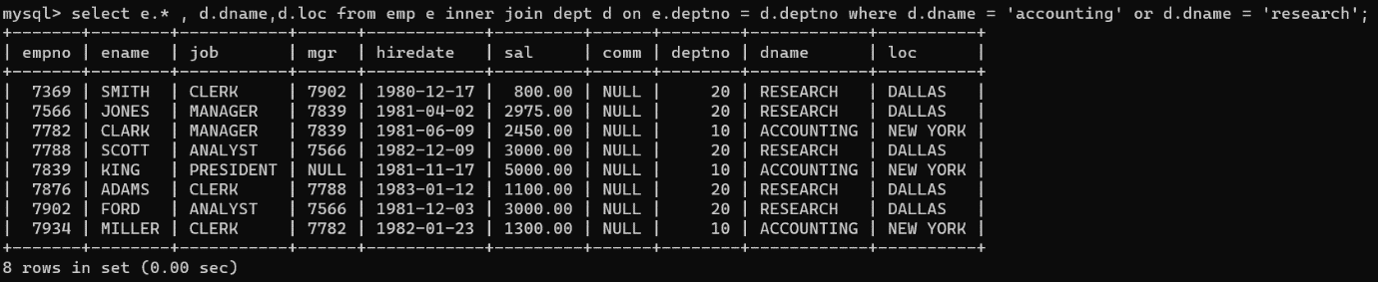

1. List the Empno, Ename, Sal, Dname of al the ‘MANAGER’ and ‘ANALYST’ working in New York or Dallas with an exp more than 7 years without receiving the Comma sc order of Loc.

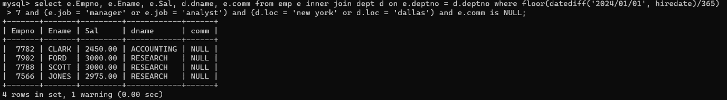

1. Display the Empno, Ename, Sal, Dname, Log, Deptno, Job of all emps working at CHICAGO or working for ACCOUNTING dept with Ann sal >28000, but the Sal should not be = 3000 or 2800, Who doesn’t belongs to the Manager and Whose No. having a digit ‘7’ or ‘8’ in 3rd position in the asc order of Deptno and desc order of Job.
2. Display the total information of the emps along with Grades I the asc order of grade.
3. List all the grade 2 and Grade 3 emps.
4. Display all grade 4.5 Analyst and Manager.
5. List the Empno, Sal, Dname, grade, Experience and Annual sal of emps working for Dept 10 or 20.
6. List the details of the Depts along with Empno, Ename or without the emps.
7. List the emps whose are senior to their own Manager.
8. List the emps of Deptno 20 whose Jobs are same as Deptno 10.
9. List the emps whose Salary is same as FORD or SMITH in desc order of Salary.
10. List the emps whose Jobs are sale as MILLER or Sal is more than ALLEN.
11. List the emps whose Sal is more than the total remuderation of the SALESMAN. 126. List the emps who are senior to BLAKE working at CHICAGO & BOSTON.
12. List the emps of Grade 3,4 belongs to the dept ACCOUNTING and RESEARCH whose Sal is more than ALLEN and exp more than SMITH in the asc order of Exp.
13. List the emps whose jobs same as SMITH or ALLEN.
14. List the most recently hired employee of Grade 3 belongs to the Loc CHICAGO. 130. List the emps with their Dept names.
15. List the emps who are not working in ‘Sales’ dept.
16. List the emps Name, Dept, Sal & Comm for those whose Salary is between 2000 and 5000 and Loc is Chicago.
17. List the emps whose Salary is greater than his Manager’s salary.
18. List the Grade, Ename for the Deptno 10 or 30 but grade is not 4 while they joined in the company before ’31-Dec-82’.
19. List the ename, Job, Dname, Loc for those who are working as a MANAGERS.
20. List the emps whose Manager name is ‘Jones’ & also List their Manager names. 137. List the Name and Salary of Ford if his Salary is equal to Hisal of his Grade.
21. List the Name, Job, Dname, Mgrno, Salary, grade Dept wise.
22. List the emps Name, Job and MGR without Manager.
23. List the Name, Salary, Comm for those emps whose Net pay is greater than or equal to any other employee Salary of the company.
24. List the emps whose Sal is less than his Manager but more than other Managers.
25. List the Mgrs who are not working under ‘President’ but working under other Manager.
26. List the emps who joined in the company on the same date.
27. List the employee Name, Job, Annual salary, Deptno, dept name, and grade who earn 36000 a year and who are not CLERKS.
28. List the Name, Job and Salary of the emps who are not belonging to the department

10 but who have the same Job or Salary as the emps of dept 10 146. List the details of emps working at Chicago.

1. List the Empno, Ename, deptno, loc of all emps.
2. List the Empno, Ename, loc of dname of the depts.10 or 20.
3. List the empno, Sal, loc of emps working at Chicago sal as with an exp>6y.
4. List the emps along with of those who belongs to Dallas New York with Sal ranging from 2000 to 5000 joined in 1981.
5. List the Empno, Ename, Sal, grade of all emps.
6. List the grade 2 & 3 emps of Chicago.
7. List the emps with loc & grade of Accounting dept or the location Dallas or Chicago with the grades 3 to 5 & exp >6y.
8. List the grades 3 emps of Research or Operations depts. Joined after 1987 and whose names should not be either Miller or Allen.
9. List the emps whose Job is same as Smith.
10. List the emps who are senior to Miller.
11. List the emps whose Job is same as either Allen or Sal is more than Allen sal.
12. List the emps whose Sal is greater than Blake salary.
13. List the dept 10 emps whose Sal is more than Allen Salary.
14. List the Managers who are senior to king & who are junior to Smith.
15. List the Empno, Ename, loc, Sal, Dname of all emps belongs to king dept.
16. List the emps whose grade is greater than the grade of Miller.
17. List the emps who are belongs Dallas or Chicago with the grade same as Adams or exp more than Smith.
18. List the emps whose Sal is same as Ford or Blake.
19. List the emps details of the emp of Chicago.
20. List the Empno, Ename, Sal, Experience, TA, HRA, DA and Gross and Dname of all emps joined in the year 1981 in the Loc NEWYORK and DALLAS with Sal <4500.
21. List Empno, Ename, Sal, Dname, Loc of all emps working at DALLAS, with the Sal should not more than 3500 in the desc order of sal.
22. List the information of EMP along with Loc, employee working at Loc which does not have a char ‘a’ with the annual Salary ranging from 22000 to 40000 without Comm.
23. List the Empno, Ename, Deptno and Dname of all emps belongs to RESEARCH Dept.
24. List all the emps along with Location who belongs to Depts 10 or 20.
25. List the emps whose Sal is more than Blake Sal.
26. List the emps of Deptno 10 whose Jobs are same as any emp job of deptno 20.
27. List the emps who are senior to Ward.
28. List the empno, ename, Sal, Grade of all emps who belongs to the grade 3 or 4 175. List the Empno, Ename, Sal, Grade of all emps working for the mgrs 7788, 7369, 7566.
29. List all the Grade 3 ‘Analysis and ‘managers’ in the asc order of Job.
30. List all Grade 4 emps working for Research Dept along with Grade and Dname.
31. List the emps working at Chicago with the job same as the emp of DALLAS.
32. List the emps of NEWYORK whose Job is same as any emp belongs to grade 3.
33. List the details of the emps whose Jobs are same as FORD and BLAKE.
34. List the empno, ename, sal, deptno, all emps working in Accounting or sales dept.
35. List the unique job categories of emps working at Dallas in the dest order.
36. List the emps along with the dname, those are working in location which is not having a char ‘Y’ or blank space in the ename & exp>15 Y & does not belongs the jobs president Salesman in the asc order of exp.
37. List the empno, ename, annsal, job, loc of all emps working at Chicago, Dallas with an annsal between 16000 to 52000 & whose job != Analyst working with some Mgr joined in jan to June & Nov-Dec but not belongs to year 83 or 84 in the asc order of loc.
38. List the empno, ename, sal, total details of the dept where the emps sal>3/4th of comm. And working in dept which is not located in Boston, Dallas & whose names are not having a chr ‘Z’ or ‘TH’ or ‘LL’ together & sal is 4 digit & it should not ending with 0 in the asc order of loc.
39. List all Managers & Analyst of grade 3-5 with exp 8-14 Years in the asc order of grade.
40. List the details of emps with dname, grade those who are working in Accounting belongs to grade 3.
41. List the emps with exp & annsal of those belongs to grade 1,2,3 & desig as Clerk OR Salesman at Chicago or NEW YORK working for the Mgr is not ending with

‘9’.

1. List the emps whose sal is more than Jones sal.
2. List the details of dept where President is working.
3. List the emps along with dname whose dname is same as Allen.
4. List the emps whose grade is same as Miller grade
5. List the empno, ename, sal, job, deptno, loc, grade of emps whose grade is same as the emps who are working under Blake.
6. List the emps whose jobs are same as emps job of dept 20.
7. List the emps whose jobs are not same as any employee of sales dept.
8. List the emps whose Sal is more than any emp of dept 10.
9. List the emps who are senior to all emps & who are Mgrs to others.
10. List the emps whose jobs are same as Ford or Blake.
11. List the common jobs of grade 1 & emps working at Chicago.
12. List the jobs of emps available in Chicago & not available in Dallas.
13. List those Managers who are getting the sal less than his own emps Salary.
14. Find out the emps who joined in the company before their Managers.
15. List the Deptno where there are no emps.
16. List the emps of dept 20 & 30 whose experience is more than any employee of Dept. 10.
17. Display the emps whose Grade is 3.
18. Display the Grade of ‘Jones’.
19. Display the emps who are in ‘Sales’ Dept not in Grade 3.
20. Display the emps who do not have any persons working under them.
21. Display the emps whose job is not ‘Manager’ but they are managers to some other employees.
22. Display the Dept’s whose name start with‘s’ while the Loc name ends with ‘k’. 211. Print the details of all the emps who are sub-ordinates to Blake.
23. List the emps who are working as Managers using co-related sub-query.
24. List the emps whose Managers name is ‘Jones’ and also with their managers name.